**Predict impact of new menu.**

**Planning the analysis.**

**Overview.**

Round Roasters, a coffee restaurant in the United States of America, conducted a market test with a new menu and needs to figure whether the new menu can drive enough sales to offset the cost of marketing the new menu. This project is to analyse the A/B test and write up a recommendation to whether the Round Roasters chain should launch this new menu.

**What is the test period?**

Testing of the new menu lasted 12 weeks from 2016-04-29 through to 2016-07-21.

For the analysis, trend and seasonality will need to be calculated for matching of control and treatment units. This process requires 52 weeks of historical data plus another 6 periods of data on top. Since the testing was done over a 12 week period, each period being 1 week, the total number of weeks needed for analysis is below:

|  |  |
| --- | --- |
| **Item** | **Period** |
| Historical Analysis | 52 weeks |
| Trend Analysis | 6 weeks |
| Testing | 12 weeks |
| **Total** | 70 weeks |

This means start date for the data needed is 2015-03-20 through to 2016-07-21.

**Should the transaction data be aggregated?**

The transaction data for Round Roasters Stores will need to be filtered for the above mentioned periods. The remaining data will need to be aggregated by the following:

|  |
| --- |
| Weekly period |
| Invoices as an indication of store traffic |
| Store ID |
| Gross Margin |
| Sales |

**What variables will be used to match treatment units to control units?**

Below are the variables used to match control units to treatment units:

|  |
| --- |
| Trend |
| Seasonality |
| Sq_ft |
| Average Monthly Sales per Store |

**Analysis.**

**Below are the results of the A/B Tests.**

Lift Analysis for Control vs Treatment for the Central Region.

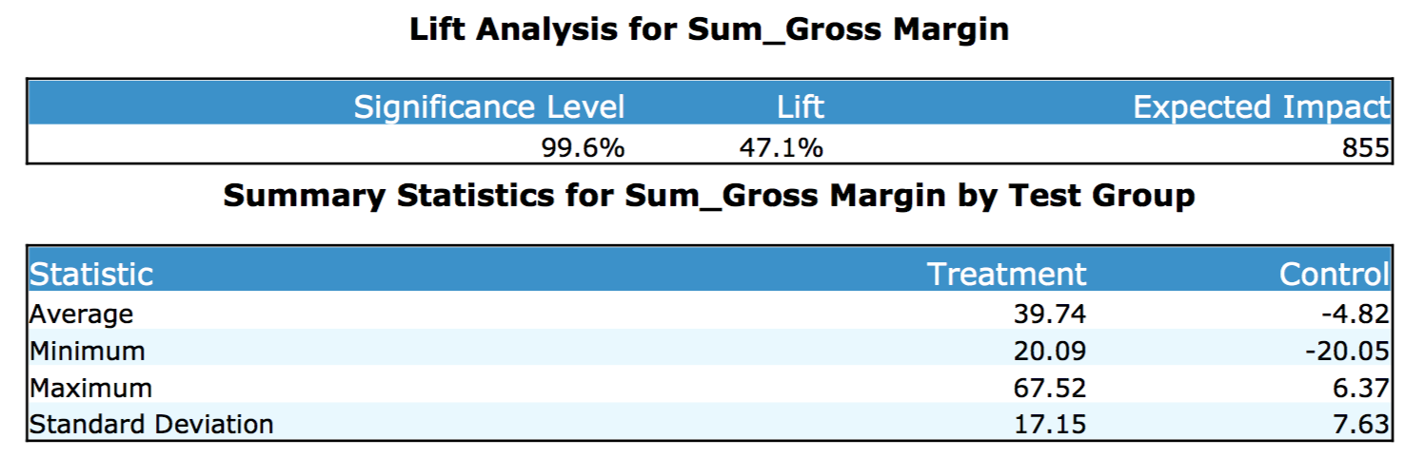

Lift Analysis for Control vs Treatment for the West Region.

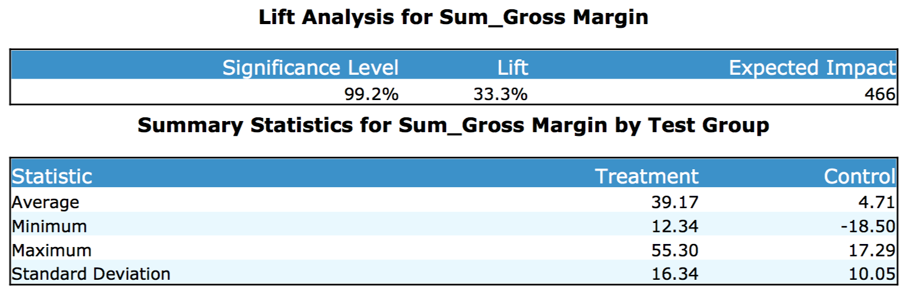

Lift Analysis for Control vs Treatment for the Combined Region (West & Central).

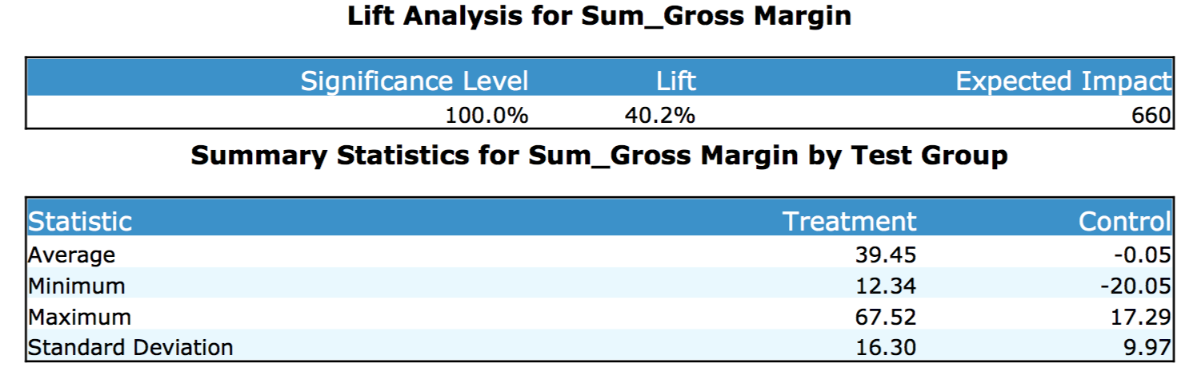

Box and Whisker plot for the Combined Region (West & Central) indicating percent change in Gross Margin.

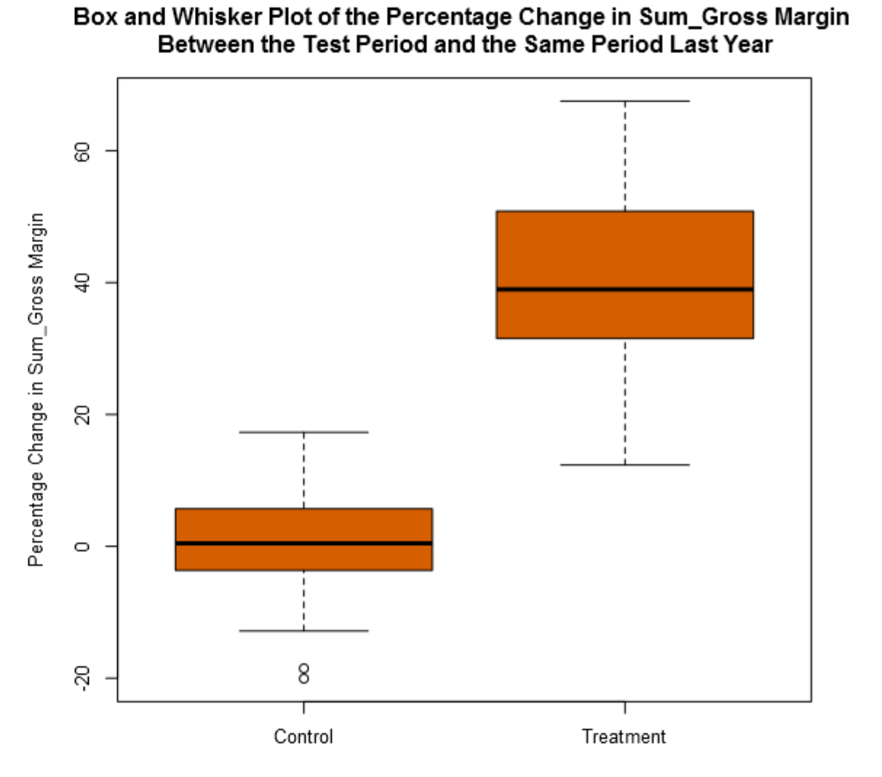

**Conclusion.**

**Final recommendation.**

In conclusion, I would recommend Round Roasters implement the new menu to all stores due to a lift of 40.2% at a significance of 100%

**Lift from the new menu for the West & Central Region.**

|  |  |  |
| --- | --- | --- |
| Region | Lift | Significance Level |
| West | 33.3% | 99.2% |
| Central | 47.1% | 99.6% |

**Lift from the new menu for the Combined Region (West & Central).**

|  |  |  |
| --- | --- | --- |
| Region | Lift | Significance Level |
| Combined (West & Central) | 40.2% | 100% |